- Executive Summary
This document describes the analysis and migration of Wkfl_SSP_FINC_LOB_DIM, an Informatica PowerCenter workflow responsible for maintaining the Financial Line of Business (LOB) Dimension table (SSP_FINC_LOB_DIM) in the data warehouse. The workflow propagates LOB reference data across three data layers — ODS/Staging, EDM (Enterprise Data Model), and DW (Data Warehouse) — through two sequentially executed sessions.
Session 1 (s_m_ODS_EDM_SSP_FINC_LOB_DIM_V1) reads new LOB identifiers (FNCL_LOB_ID) detected in the ODS staging table (SSP_STG.SSP_STG_OSF_L2_CUST_MSTR) and bootstraps placeholder dimension records into the EDM intermediate table (SSP_FINC_LOB_DIM_V1) with default constant values. Only one column originates from the source — all remaining attributes are assigned hardcoded defaults (e.g., 'UNKNOWN', 'ARBOR', 'ODS') at the Expression transformation layer, pending enrichment from authoritative upstream systems.
Session 2 (s_m_EDM_DW_SSP_FINC_LOB_DIM) reads the enriched and fully attributed records from EDM.SSP_FINC_LOB_DIM_V1 — the output of Session 1 — and promotes them into the final DW dimension table (SSP_FINC_LOB_DIM). Both sessions implement an insert-or-update pattern using a Lookup + Router combination: a lookup determines whether the LOB already exists in the target, and a Router directs new records to insert and existing records to update.

2. Workflow Overview
Wkfl_SSP_FINC_LOB_DIM│
├── Session: s_m_EDM_DW_SSP_FINC_LOB_DIM
│ └── Mapping: m_EDM_DW_SSP_FINC_LOB_DIM
│ ├── Source Qualifier: SQ_SSP_FINC_LOB_DIM_V1
│ ├── Expression: EXP_STANDARDIZE
│ ├── Lookup Procedure: LKP_SSP_FINC_LOB_DIM
│ ├── Router: RTR_INSERT_UPDATE
│ ├── Update Strategy: UPD_UPDATE
│ ├── Target: INS_SSP_FINC_LOB_DIM
│ └── Target: UPD_SSP_FINC_LOB_DIM
│
├── Session: s_m_ODS_EDM_SSP_FINC_LOB_DIM_V1
│ └── Mapping: m_ODS_EDM_SSP_FINC_LOB_DIM_V1
│ ├── Source Qualifier: SQ_SSP_STG_OSF_L2_CUST_MSTR
│ ├── Expression: EXP_SSP_STG_OSF_L2_CUST_MSTR
│ ├── Lookup Procedure: LKP_SSP_FINC_LOB_DIM_V1
│ ├── Router: RTR_INSERT_UPDATE
│ ├── Target: SSP_FINC_LOB_DIM_V1
│ └── Target: UPD_SSP_FINC_LOB_DIM_V1

** The graph model is missing CMD tasks so they don’t show up here

3. s_m_ODS_EDM_SSP_FINC_LOB_DIM_V1 Narrative

Step 1: Read Source Data
Transformation name: SQ_SSP_STG_OSF_L2_CUST_MSTR
The workflow reads customer records from SSP_STG.SSP_STG_OSF_L2_CUST_MSTR.
Retrieved attributes include:
- FNCL_LOB_ID

Step 2: Expression
Transformation: EXP_SSP_STG_OSF_L2_CUST_MSTR
Expressions:
Expression list (column: expression)
- IsCurrent: 1
- SRCSYSID: 1
- FINC_LOB_ARBR_CD: 'ARBOR'
- FINC_LOB_NM: 'UNKNOWN'
- FINC_LOB_BUS_NM: 'UNKNOWN'
- FINC_LOB_BUS_NM_UAT: 'UNKNOWN'
- FINC_LOB_HRCHY_ID: 'UNKNOWN'
- ACTV_DT: SESSSTARTTIME
- INACTV_DT: "TO_DATE('31-DEC-9999', 'DD-MON-YYYY')"
- IS_ACTV_IND: 'Y'
- DIM_SRC_CD: 'ODS'
- DIM_LAST_MDFD_DT: SESSSTARTTIME
- FINC_LOB_HRCHY_LVL: 'UNKNOWN'
Input columns
- FNCL_LOB_ID
Output columns
- FNCL_LOB_ID
- IsCurrent
- SRCSYSID
- FINC_LOB_ARBR_CD
- FINC_LOB_NM
- FINC_LOB_BUS_NM
- FINC_LOB_BUS_NM_UAT
- FINC_LOB_HRCHY_ID
- ACTV_DT
- INACTV_DT
- IS_ACTV_IND
- DIM_SRC_CD
- DIM_LAST_MDFD_DT
- FINC_LOB_HRCHY_LVL

Step 3: Reference Data Enrichment (Lookup)
Transformation: LKP_SSP_FINC_LOB_DIM
Join condition: FINC_LOB_CD = FNCL_LOB_ID
tableName: SSP_FINC_LOB_DIM_V1

Input columns:
- FNCL_LOB_ID
Output columns:
- SSP_FINC_LOB_DIM_Key

Step 4: Data Filtering (Router)
Transformation: RTR_INSERT_UPDATE
Groups (name: condition)
- Input: N/A
- INSGRP: ISNULL(SSP_FINC_LOB_CD_DIM_Key)
- UPDGRP: IIF(ISNULL(SSP_FINC_LOB_CD_DIM_Key),TRUE,FALSE)
- DEFAULT1: N/A
Input/Output columns:
- FNCL_LOB_ID
- IsCurrent
- SRCSYSID
- FINC_LOB_ARBR_CD
- FINC_LOB_NM
- FINC_LOB_BUS_NM
- FINC_LOB_BUS_NM_UAT
- FINC_LOB_HRCHY_ID
- ACTV_DT
- INACTV_DT
- IS_ACTV_IND
- DIM_SRC_CD
- DIM_LAST_MDFD_DT
- FINC_LOB_HRCHY_LVL
- SSP_FINC_LOB_DIM_Key

Step 4: Record Updates
Transformation: UPD_SSP_FINC_LOB_DIM
Target: SSP_FINC_LOB_DIM
Settings:
- Tracing level: normal
- Update Strategy Expression: DD_UPDATE
- Forward Rejected Rows: yes
Input columns:
- FNCL_LOB_ID
- IsCurrent
- SRCSYSID
- FINC_LOB_ARBR_CD
- FINC_LOB_NM
- FINC_LOB_BUS_NM
- FINC_LOB_BUS_NM_UAT
- FINC_LOB_HRCHY_ID
- ACTV_DT
- INACTV_DT
- IS_ACTV_IND
- DIM_SRC_CD
- DIM_LAST_MDFD_DT
- FINC_LOB_HRCHY_LVL
- SSP_FINC_LOB_DIM_Key
Output columns:
- IsCurrent
- SRCSYSID
- FINC_LOB_ARBR_CD
- FINC_LOB_NM
- FINC_LOB_BUS_NM
- FINC_LOB_BUS_NM_UAT
- FINC_LOB_HRCHY_ID
- ACTV_DT
- INACTV_DT
- IS_ACTV_IND
- DIM_SRC_CD
- DIM_LAST_MDFD_DT
- FINC_LOB_HRCHY_LVL
- SSP_FINC_LOB_DIM_Key

Step 5: Record Inserts
Transformation: INS_SSP_FINC_LOB_DIM
Target: SSP_FINC_LOB_DIM
Input columns:
- FNCL_LOB_ID
- IsCurrent
- SRCSYSID
- FINC_LOB_ARBR_CD
- FINC_LOB_NM
- FINC_LOB_BUS_NM
- FINC_LOB_BUS_NM_UAT
- FINC_LOB_HRCHY_ID
- ACTV_DT
- INACTV_DT
- IS_ACTV_IND
- DIM_SRC_CD
- DIM_LAST_MDFD_DT
- FINC_LOB_HRCHY_LVL
- SSP_FINC_LOB_DIM_Key

Output columns:
- FNCL_LOB_ID
- IsCurrent
- SRCSYSID
- FINC_LOB_ARBR_CD
- FINC_LOB_NM
- FINC_LOB_BUS_NM
- FINC_LOB_BUS_NM_UAT
- FINC_LOB_HRCHY_ID
- ACTV_DT
- INACTV_DT
- IS_ACTV_IND
- DIM_SRC_CD
- DIM_LAST_MDFD_DT
- FINC_LOB_HRCHY_LVL

4. s_m_EDM_DW_SSP_FINC_LOB_DIM Narrative

Step 1: Read Source Data
Transformation name: SQ_SSP_FINC_LOB_DIM_V1
The workflow reads records from EDM.SSP_FINC_LOB_DIM_V1.
Retrieved attributes include:
- ACTV_DT
- DIM_LAST_MDFD_DT
- DIM_SRC_CD
- EndDate
- FINC_LOB_ARBR_CD
- FINC_LOB_BUS_NM
- FINC_LOB_BUS_NM_UAT
- FINC_LOB_CD
- FINC_LOB_HRCHY_ID
- FINC_LOB_HRCHY_LVL1
- FINC_LOB_HRCHY_LVL2
- FINC_LOB_HRCHY_LVL3
- FINC_LOB_NM
- INACTV_DT
- IS_ACTV_IND
- IsCurrent
- SSP_FINC_LOB_DIM_Key
- SourceSystemID
- SourceSystemKey
- StartDate

Step 2: Reference Data Enrichment (Lookup)
Transformation: LKP_SSP_FINC_LOB_DIM
Join condition: FINC_LOB_CD = IN_FINC_LOB_CD
tableName: SSP_FINC_LOB_DIM

Input columns:
- IN_FINC_LOB_CD
Output columns:
- FINC_LOB_CD_SK

Step 3: Data Filtering (Router)
Transformation: RTR_INSERT_UPDATE
Transformation: RTR_INSERT_UPDATE
Groups (name: condition)
- Input: N/A
- INSGRP: ISNULL(FINC_LOB_CD_SK)
- UPDGRP: IIF(NOT ISNULL(FINC_LOB_CD_SK),TRUE,FALSE)
- DEFAULT1: N/A

Input/Output columns:
- ACTV_DT
- DIM_LAST_MDFD_DT
- DIM_SRC_CD
- EndDate
- FINC_LOB_ARBR_CD
- FINC_LOB_BUS_NM
- FINC_LOB_BUS_NM_UAT
- FINC_LOB_CD
- FINC_LOB_HRCHY_ID
- FINC_LOB_HRCHY_LVL1
- FINC_LOB_HRCHY_LVL2
- FINC_LOB_HRCHY_LVL3
- FINC_LOB_NM
- INACTV_DT
- IS_ACTV_IND
- IsCurrent
- SSP_FINC_LOB_DIM_Key
- SourceSystemID
- SourceSystemKey
- StartDate
- FINC_LOB_CD_SK

Step 4: Record Updates
Transformation: UPD_SSP_FINC_LOB_DIM
Target: SSP_FINC_LOB_DIM

Settings:
- Tracing level: normal
- Update Strategy Expression: DD_UPDATE
- Forward Rejected Rows: yes

Input columns:
- ACTV_DT
- DIM_LAST_MDFD_DT
- DIM_SRC_CD
- EndDate
- FINC_LOB_ARBR_CD
- FINC_LOB_BUS_NM
- FINC_LOB_BUS_NM_UAT
- FINC_LOB_CD
- FINC_LOB_HRCHY_ID
- FINC_LOB_HRCHY_LVL1
- FINC_LOB_HRCHY_LVL2
- FINC_LOB_HRCHY_LVL3
- FINC_LOB_NM
- INACTV_DT
- IS_ACTV_IND
- IsCurrent
- SSP_FINC_LOB_DIM_Key
- SourceSystemID
- SourceSystemKey
- StartDate

Output columns:
- ACTV_DT
- DIM_LAST_MDFD_DT
- DIM_SRC_CD
- FINC_LOB_ARBR_CD
- FINC_LOB_BUS_NM
- FINC_LOB_BUS_NM_UAT
- FINC_LOB_CD
- FINC_LOB_HRCHY_ID
- FINC_LOB_HRCHY_LVL1
- FINC_LOB_HRCHY_LVL2
- FINC_LOB_HRCHY_LVL3
- FINC_LOB_NM
- INACTV_DT
- IS_ACTV_IND

Step 5: Record Inserts
Transformation: INS_SSP_FINC_LOB_DIM

Target: SSP_FINC_LOB_DIM

Input columns:
- ACTV_DT
- DIM_LAST_MDFD_DT
- DIM_SRC_CD
- EndDate
- FINC_LOB_ARBR_CD
- FINC_LOB_BUS_NM
- FINC_LOB_BUS_NM_UAT
- FINC_LOB_CD
- FINC_LOB_HRCHY_ID
- FINC_LOB_HRCHY_LVL1
- FINC_LOB_HRCHY_LVL2
- FINC_LOB_HRCHY_LVL3
- FINC_LOB_NM
- INACTV_DT
- IS_ACTV_IND
- IsCurrent
- SSP_FINC_LOB_DIM_Key
- SourceSystemID
- SourceSystemKey
- StartDate

Output columns:
- FINC_LOB_HRCHY_ID
- INACTV_DT
- ACTV_DT
- FINC_LOB_HRCHY_LVL1
- FINC_LOB_HRCHY_LVL2
- FINC_LOB_HRCHY_LVL3
- DIM_SRC_CD
- FINC_LOB_CD
- IS_ACTV_IND
- SSP_FINC_LOB_DIM_Key
- FINC_LOB_BUS_NM
- FINC_LOB_BUS_NM_UAT
- DIM_LAST_MDFD_DT
- FINC_LOB_HRCHY_ID
- FINC_LOB_NM
- FINC_LOB_ARBR_CD

4. Business Rules Extracted
Default values (column: value):
- SRCSYSID: 1
- FINC_LOB_ARBR_CD: 'ARBOR'
- FINC_LOB_NM: 'UNKNOWN'
- FINC_LOB_BUS_NM: 'UNKNOWN'
- FINC_LOB_BUS_NM_UAT: 'UNKNOWN'
- FINC_LOB_HRCHY_ID: 'UNKNOWN'
- ACTV_DT: SESSSTARTTIME
- INACTV_DT: "TO_DATE('31-DEC-9999', 'DD-MON-YYYY')"
- IS_ACTV_IND: 'Y'
- DIM_SRC_CD: 'ODS'
- DIM_LAST_MDFD_DT: SESSSTARTTIME
- FINC_LOB_HRCHY_LVL: 'UNKNOWN'

5. Source-to-Target Mapping

5A. Mapping: m_ODS_EDM_SSP_FINC_LOB_DIM_V1
- Source: SSP_STG.SSP_STG_OSF_L2_CUST_MSTR
- Target: EDM.SSP_FINC_LOB_DIM_V1

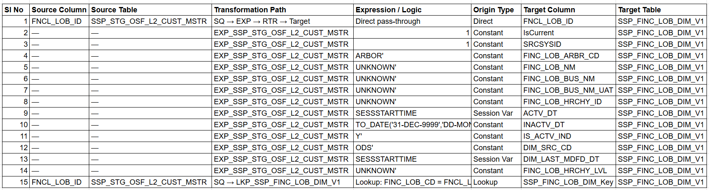

Routing logic (RTR_INSERT_UPDATE):
INSGRP:
ISNULL(SSP_FINC_LOB_DIM_Key) → new record, goes to insert target SSP_FINC_LOB_DIM_V1
UPDGRP:
NOT ISNULL(SSP_FINC_LOB_DIM_Key) → existing record, goes to update target UPD_SSP_FINC_LOB_DIM_V1
Note: This mapping is a seed/bootstrap mapping. Only FNCL_LOB_ID originates from the source table. All 13 remaining columns are either hardcoded constants or session-time variables, indicating

this mapping creates placeholder LOB dimension records with default values when a new LOB ID is detected.
5B. Mapping: m_EDM_DW_SSP_FINC_LOB_DIM
- Source: EDM.SSP_FINC_LOB_DIM_V1
- Target: DW.SSP_FINC_LOB_DIM

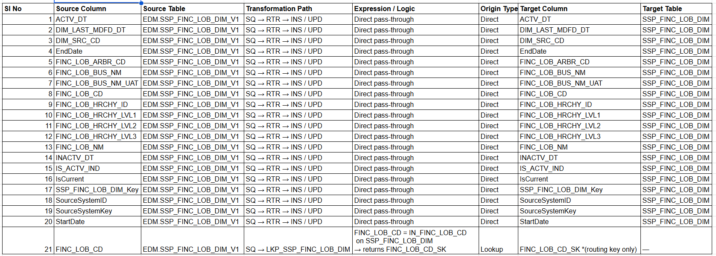
Routing logic (RTR_INSERT_UPDATE):
INSGRP:
ISNULL(FINC_LOB_CD_SK) → new record, goes to insert target INS_SSP_FINC_LOB_DIM
UPDGRP:
NOT ISNULL(FINC_LOB_CD_SK) → existing record, goes to update target UPD_SSP_FINC_LOB_DIM (strategy: DD_UPDATE)

Neo4j Cypher Queries to Generate This Mapping
- Query 1 — Full field-level source-to-target column lineage:
MATCH (srcField:Column:Field)-[:BOUND_TO_PORT]->(srcPort:Column:Port)
-[:FLOWS_TO*1..10]->(tgtPort:Column:Port)-[:BOUND_TO_FIELD]->(tgtField:Column:Field)
MATCH (srcT:Transformation)-[:HAS_PORT]->(srcPort)
MATCH (tgtT:Transformation)-[:HAS_PORT]->(tgtPort)
RETURN
srcField.name AS source_column,
srcT.name AS source_transformation,
tgtT.name AS target_transformation,
tgtField.name AS target_column
ORDER BY source_column

- Query 2 — Get all expressions applied per port (for the Expression transformation):
MATCH (m:Mapping)-[:HAS_TRANSFORMATION]->(t:Transformation)-[:HAS_PORT]->(p:Column:Port)
-[:USES_EXPRESSION]->(e:Expression)
WHERE m.name IN [
'm_ODS_EDM_SSP_FINC_LOB_DIM_V1',
'm_EDM_DW_SSP_FINC_LOB_DIM'
]
RETURN
m.name AS mapping,
t.name AS transformation,
p.name AS port_name,
p.portType AS port_type,
e.rawExpression AS expression,
e.intent AS intent
ORDER BY m.name, t.name, p.ordinalPosition

- Query 3 — Get lookup conditions (join key and lookup table):
MATCH (m:Mapping)-[:HAS_TRANSFORMATION]->(t:Transformation)-[:HAS_LOOKUP]->(lkp:LookupCondition)
WHERE m.name IN [
'm_ODS_EDM_SSP_FINC_LOB_DIM_V1',
'm_EDM_DW_SSP_FINC_LOB_DIM'
]
RETURN
m.name AS mapping,
t.name AS lookup_transformation,
lkp.tableName AS lookup_table,
lkp.joinCondition AS join_condition

- Query 4 — Get router group conditions:
MATCH (m:Mapping)-[:HAS_TRANSFORMATION]->(t:Transformation)-[:HAS_GROUP]->(rg:RouterGroup)
WHERE m.name IN [
'm_ODS_EDM_SSP_FINC_LOB_DIM_V1',
'm_EDM_DW_SSP_FINC_LOB_DIM'
]
RETURN
m.name AS mapping,
t.name AS router_transformation,
rg.name AS group_name,
rg.condition AS routing_condition
ORDER BY m.name, rg.name

- Query 5 — Full mapping summary: source field → transformation chain → target field:
MATCH (m:Mapping)-[:HAS_TRANSFORMATION]->(t:Transformation)
WHERE m.name IN [
'm_ODS_EDM_SSP_FINC_LOB_DIM_V1',
'm_EDM_DW_SSP_FINC_LOB_DIM'
]
MATCH (t)-[:HAS_PORT]->(p:Column:Port)
OPTIONAL MATCH (p)-[:USES_EXPRESSION]->(e:Expression)
OPTIONAL MATCH (srcField:Column:Field)-[:BOUND_TO_PORT]->(p)
OPTIONAL MATCH (p)-[:BOUND_TO_FIELD]->(tgtField:Column:Field)
RETURN
m.name AS mapping,
t.name AS transformation,
t.type AS transformation_type,
p.name AS port_name,
p.portType AS port_type,
e.rawExpression AS expression,
srcField.name AS bound_source_field,
tgtField.name AS bound_target_field
ORDER BY m.name, t.name, p.ordinalPosition

6. Lineage Summary
Section 6 – Lineage Flow Diagram | Wkfl_SSP_FINC_LOB_DIM
This workflow (Wkfl_SSP_FINC_LOB_DIM) moves Financial LOB dimension data across three data layers in two sequential sessions. Session 1 feeds Session 2 — the output table of Session 1 (EDM.SSP_FINC_LOB_DIM_V1) is the direct source of Session 2.]

Session 1 — m_ODS_EDM_SSP_FINC_LOB_DIM_V1
- Layer: ODS/Staging → EDM (Intermediate Dimension)
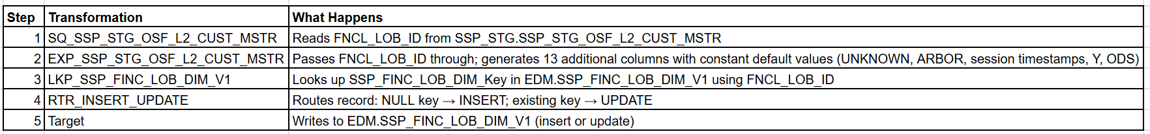

- Summary:
SSP_STG.SSP_STG_OSF_L2_CUST_MSTR
↓ (FNCL_LOB_ID)
EXP_SSP_STG_OSF_L2_CUST_MSTR ← constant defaults applied here
↓
LKP_SSP_FINC_LOB_DIM_V1 ← checks EDM.SSP_FINC_LOB_DIM_V1
↓
RTR_INSERT_UPDATE
├── INSERT → EDM.SSP_FINC_LOB_DIM_V1 (new LOB ID)
└── UPDATE → EDM.SSP_FINC_LOB_DIM_V1 (existing LOB ID)

Session 2 — m_EDM_DW_SSP_FINC_LOB_DIM
- Layer: EDM (Intermediate Dimension) → DW (Final Dimension)
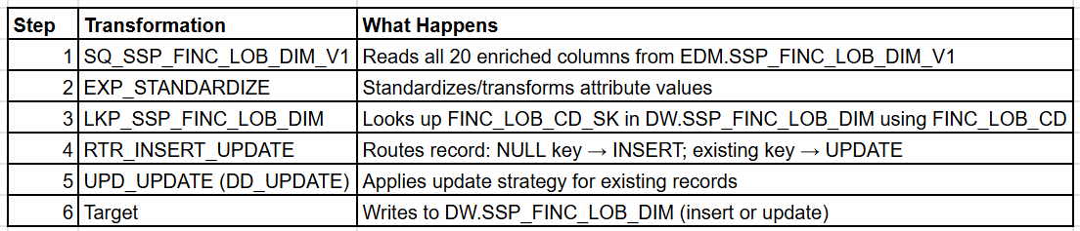
- Summary:
EDM.SSP_FINC_LOB_DIM_V1 ← output of Session 1
↓ (all 20 columns)
EXP_STANDARDIZE
↓
LKP_SSP_FINC_LOB_DIM ← checks DW.SSP_FINC_LOB_DIM
↓
RTR_INSERT_UPDATE
├── INSERT → INS_SSP_FINC_LOB_DIM → DW.SSP_FINC_LOB_DIM (new record)
└── UPDATE → UPD_UPDATE (DD_UPDATE) → DW.SSP_FINC_LOB_DIM (existing record)

End-to-End Lineage
ODS Layer EDM Layer DW Layer
───────────────────── ───────────────────── ─────────────────────
SSP_STG_OSF_L2_CUST_MSTR
│ FNCL_LOB_ID only
│
▼ Session 1
EXP (add defaults)
LKP (check EDM) ──► SSP_FINC_LOB_DIM_V1
RTR (insert/update) │ all 20 columns
│
▼ Session 2
EXP_STANDARDIZE
LKP (check DW) ──► SSP_FINC_LOB_DIM
RTR (insert/update) (final dimension)
Key inter-mapping dependency: EDM.SSP_FINC_LOB_DIM_V1 is both the write target of Session 1 and the read source of Session 2. Session 1 must complete successfully before Session 2 executes. This table acts as the staging bridge between the ODS and DW layers.

7. Assumptions and Context Layer Insights
7.1 Conversion Framework
- Each Informatica mapping is extracted as a self-contained JSON subgraph by kg_extractor.py and passed to converter.py, which assembles the system prompt + subgraph payload and calls the API.
- The converter targets Google BigQuery SQL using a CTE (WITH clause) chaining pattern — each transformation stage in Informatica becomes a named CTE (cte_SQ_, cte_EXP_, cte_LKP_, etc.) in the output SQL.
- The Router + Update Strategy combination is collapsed into a single BigQuery MERGE statement. There is no direct equivalent of Informatica's Router in BigQuery. The routing conditions become the WHEN MATCHED / WHEN NOT MATCHED predicates of the MERGE.
- All workflows are treated as on-demand (no schedule). Generated Airflow DAGs default to schedule=None.
- BigQuery table references use parameterized placeholders: `@{PROJECT_ID}.@{DATASET}.<table_name>` and these must be resolved before deployment.
7.2 Function Translation Assumptions
The following Informatica expression functions are assumed to have direct BigQuery equivalents, as defined in the context_layer.function_map:
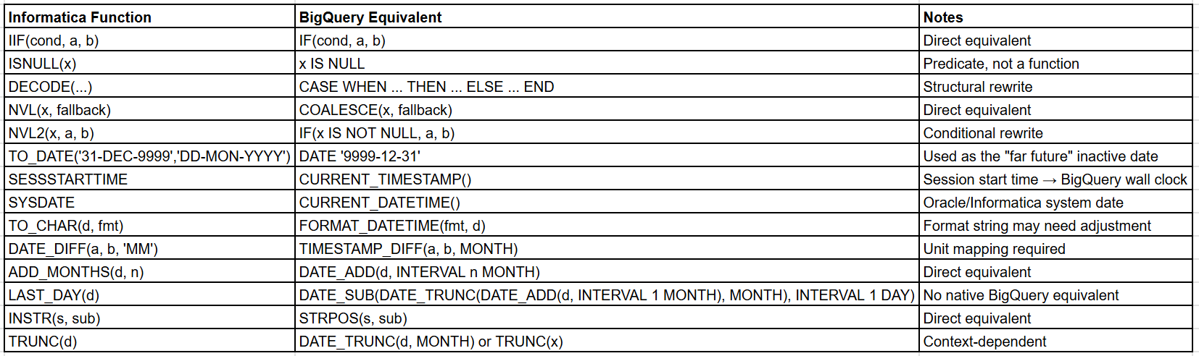
Key assumption: All CURRENT_TIMESTAMP() and CURRENT_DATETIME() calls are wrapped as TIMESTAMP(expr, 'America/New_York') to enforce timezone consistency. Informatica SESSSTARTTIME is timezone-naive; this wrapping is an explicit assumption about the operational timezone of the target environment.

7.3 Data Type Mapping Assumptions
All Informatica/Teradata/SQL Server data types are mapped to BigQuery types as follows:
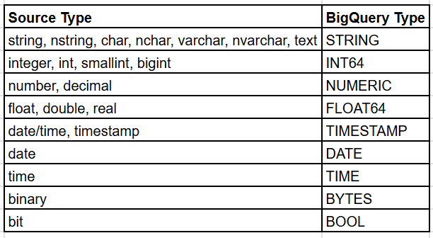
Assumption: All string-family types are unified into BigQuery STRING. No distinction is made between fixed-length (CHAR) and variable-length (VARCHAR) types, as BigQuery does not have this distinction.

7.4 Transformation Pattern Assumptions
